The   
**S**ociety of   
**F**light   
**T**est   
**P**rofessionals

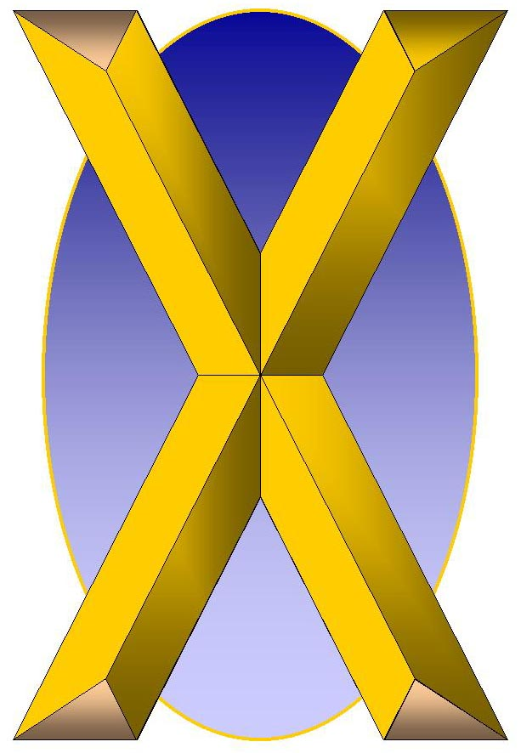

**P**



A Modest Proposal for Preventing the Dilution of Effort Among Like-Minded Professionals and For Making the Society Most Beneficial to Flight Test

# Bottom Line Up Front

Given that

1. Flight test is a unique discipline among technical endeavors
2. Flight test is fundamentally a team sport
3. Flight test is a complex activity that requires the telling of stories to distill its patterns and principles

The formation of a singular Society of Flight Test Professionals (SFTP) will best serve the improvement of safety, the development of flight test teams, and the sharing of information.

Bottom Line Up Front 1

Mission Statements 2

Membership Grades & Dues 3

Sections & Chapters 5

Symposia & Meetings 7

Awards 8

# Mission Statements

## SETP

To broaden **professional** ***relationships*** through the ***sharing of ideas and experiences*** which ***promote and enhance*** safety, **communication** and education.

To prevent accidents and loss of life by ***improving*** safety, design and **flight test** of **aerospace** **vehicles** and their related systems.

To provide a forum to ***disseminate information*** to those in the **aerospace** **industry** for the benefit of ***all aviation users***.

## SFTE

The Society of Flight Test Engineers is a fraternity of engineers, whose principal **professional** interest is the **flight testing** of **aerospace** **vehicles**.

The objective of the Society is the ***advancement*** of **flight test** engineering throughout the **aerospace** **industry** by providing ***technical and fraternal*** **communication** among ***individuals***, both domestic and international, in the allied engineering fields of ***test*** ***operations, analysis, instrumentation and data systems***.

## SFTP

To broaden professional relationships among flight test professionals through the sharing of ideas and experiences which promote and enhance safety, communication and education.

To prevent accidents and loss of life by improving safety, design and flight test of aerospace vehicles and their related systems.

To provide a forum to disseminate information to those in the aerospace industry for the benefit of all aviation users.

# Membership Grades & Dues

|  |  |
| --- | --- |
| SETP | SFTE |
|  | **Student Member:**  Annual dues, $15 |
| **Provisional Associate Member:**  No fee (?), 3 years to achieve experience necessary for Associate Member or Member status |  |
| **Associate Member:**  Initiation fee, $40  Annual dues, $125 | **Associate Member:**  Annual dues, $55 |
| **Member:**  Initiation fee, $125  Annual dues, $135 | **Member:**  Annual dues, $55 |
|  | **Senior Member:**  Annual dues, $55 |
| **Associate Fellow:**  Annual dues, $135 |  |
| **Fellow:**  Annual dues, $135 | **Fellow:**  Free lifetime membership |
| **Honorary Fellow** |  |
| **Corporate** | **Corporate \ Affiliate Member** |

## SFTP

1. SETP membership provides access to the SETP Scholarship Foundation.[1] This is a major benefit of SETP membership, and one that should be considered with due diligence. The primary assumptions regarding the Scholarship Foundation include:
   1. The member is/was an active test pilot.
   2. The member is/was paying the dues prior to the event leading to the assistance.
   3. SETP dues are significantly greater than SFTE dues.
2. SETP is inherently exclusive. That is, membership is meant to be for a narrowly defined set of individuals, excluding all but pilots actively engaged in specified flight test activities.
3. SFTE is inherently inclusive. That is, membership is meant to be for a broadly defined set of individuals, including current students.
4. ***SFTP*** membership can capture the benefits of each of these approaches by adding the concept of membership TYPES to the existing concept of membership GRADES.

|  |  |  |  |  |  |
| --- | --- | --- | --- | --- | --- |
| Initiation/Dues | **TYPES** | | | | |
| **GRADES** | Test Pilot* | Test Aircrew* | Test Engineer** | Affiliate |
| Student | N/A | N/A | $0 / $15 | $0 / $15 |
| Associate Member | $40 / $125 | $40 / $125 | $0 / $55 | $0 / $55 |
| Member | $125 / $135 | $125 / $135 | $0 / $55 | $0 / $55 |
| Associate Fellow | $0 / $135 | $0 / $135 | $0 / $55 | $0 / $55 |
| Fellow | $0 / $135 | $0 / $135 | Free Lifetime | Free Lifetime |
| Corporate | N/A | N/A | N/A | Pro-Rated |

*Access to Scholarship Foundation, ** Test Engineer may also be Test Aircrew

# Sections & Chapters

## setp sections

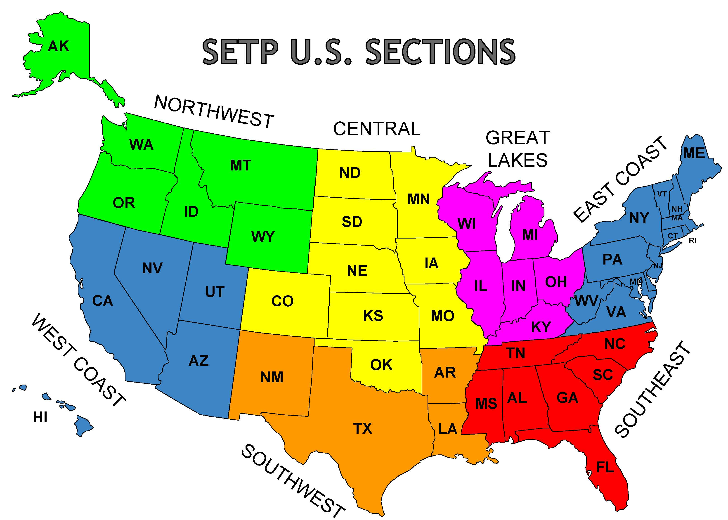

* EUROPEAN
* CANADIAN

## SFTE chapters

* Antelope Valley
* Canadian
* China Lake
* Coastal Empire
* Emerald Coast
* Europe
* Los Angeles
* New Mexico
* North Texas
* Patuxent River
* Rocket City
* Seattle
* St Louis
* Wichita
* Wright
* Student – University of Kansas
* Student – University of Missouri
* Student – West Michigan University
* Student – Texas A&M University

## SFTP

1. SETP Sections are broad geographic areas that encourage cross-talk between different locations.
2. SFTE Chapters are local geographic points that encourage local engagement.
3. SFTP, to capitalize on the benefits of both types of organization, will preserve both the Section and the Chapter. Single-chapter Sections will have to decide on the extent of officerships.

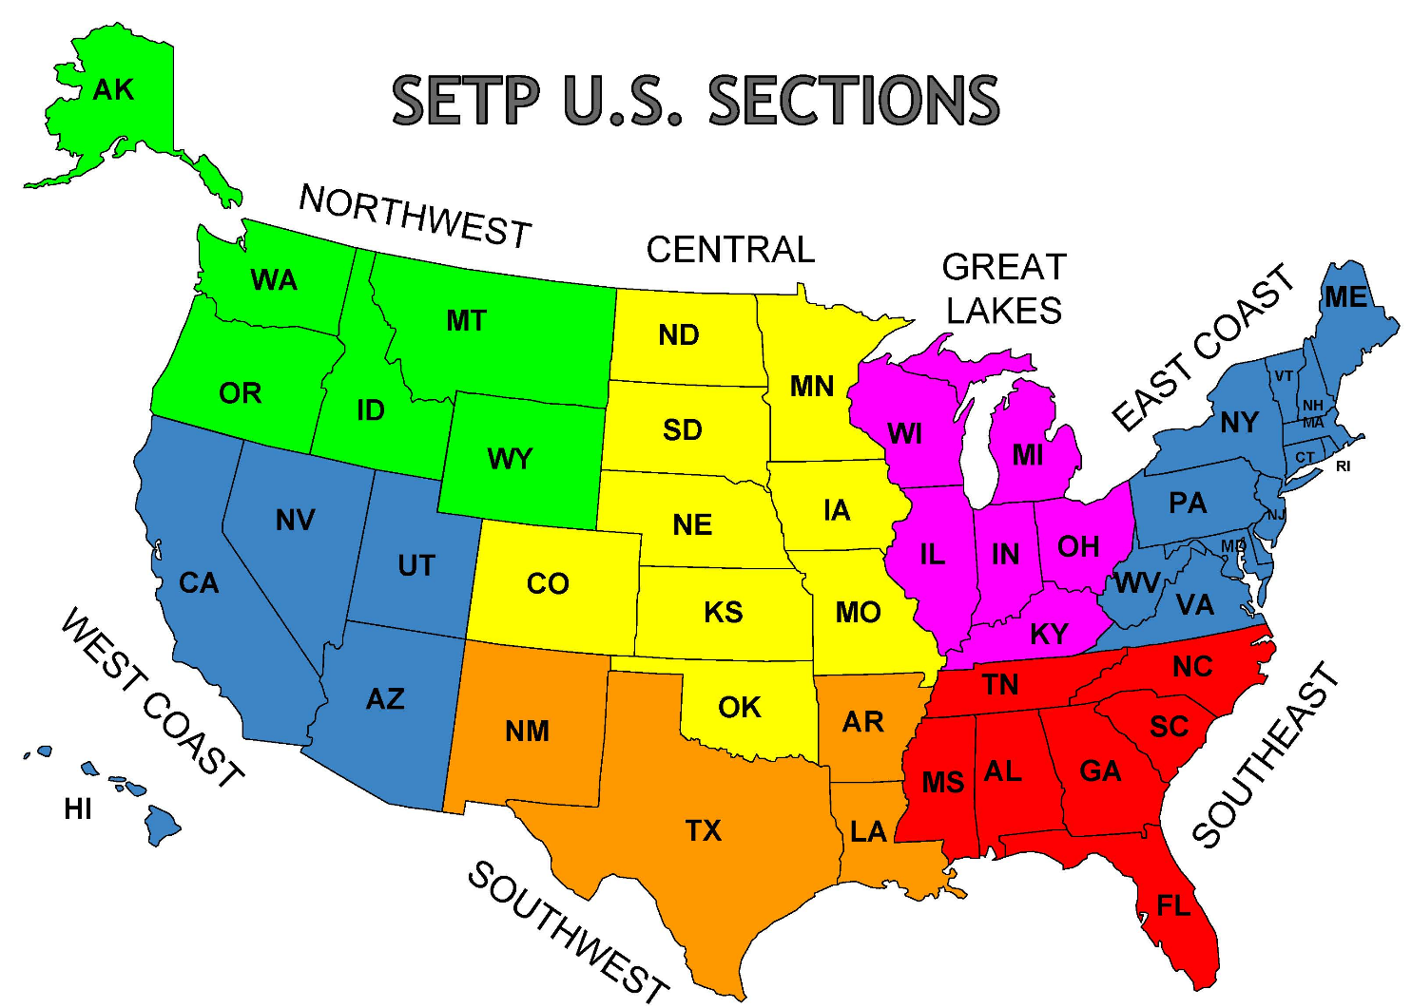

CANADIAN SECTION: CANADIAN CHAPTER

EUROPEAN SECTION: EUROPEAN CHAPTER

# Symposia & Meetings

|  |  |
| --- | --- |
| SETP | SFTE |
| **Annual**  Always Anaheim  Always last full week in September  Central Office heavily involved | **Annual**  Rotates among Chapters  ~August to November  Chapter heavily involved |
| **Section**  Every Section hosts each year  Various times, offset from Annual  Central Office assists | **Chapter**  Some Chapters  Sometimes, often close to Annual  Completely up to the Chapter |

## Flight test safety workshop

**Annual**

Location varies

May for North America, November for Europe (when Europe holds a separate workshop)

|  |
| --- |
| SFTP |
| **Annual - September**  Always Anaheim  Always last full week in September  Central Office heavily involved |
| **Section - January**  Hosted by a Chapter within the Section, rotating, if available  Always January +/- a few months  Central Office assists, Section Leadership heavily involved, Chapter assists |
| **Flight Test Safety Workshop – May**  Hosted by a Chapter, rotating  Always May  Central Office assists, FTSC heavily involved, Chapter assists |
| **European Symposium – June???**  **European Flight Test Safety Workshop – November???** |

# Awards

## KEEP ‘EM ALL

Eta Award

Lloyd Stearman Award

Spirit of Flight Award

Friend of the Society Award

Leroy Grumman Award

Jack Northrop Award

Ray E. Tenhoff Award

Herman R. Salmon Technical Publications Award

Tony LeVier Flight Test Safety Award

James H. Doolittle Award

Iven C. Kincheloe Award

Kelly Johnson Award (Individual Engineer)

James S. McDonnell Award (Test Team)

SFTE Fellow Award

# governance

|  |  |
| --- | --- |
| SETP (1-year terms) | SFTE (2-year terms) |
| |  | | --- | | PRESIDENT | | PRESIDENT-ELECT | | VICE PRESIDENT | | SECRETARY | | TREASURER | | LEGAL OFFICER | | Executive Advisor | | Technical Advisor | | Technical Advisor | | Canadian Section Representative | | Central Section Representative | | East Coast Section Representative | | European Section Representative | | Great Lakes Section Representative | | Northwest Section Representative | | Southeast Section Representative | | Southwest Section Representative | | West Coast Section Representative | | |  | | --- | | President | | Vice President | | Secretary | | Treasurer | | Directors At Large | | Editor | | Technical Council | | Webmaster | | Antelope Valley Chapter President | | Canadian Chapter President | | China Lake Chapter President | | Coastal Empire Chapter President | | Emerald Coast Chapter President | | Europe Chapter President | | Los Angeles Chapter President | | New Mexico Chapter President | | North Texas Chapter President | | Patuxent River Chapter President | | Rocket City Chapter President | | Seattle Chapter President | | St. Louis Chapter President | | Wichita Chapter President | | Wright Chapter President | |
| Staff:  Executive Director  Office Manager  Administrator  SETP Foundation, Scholarship Foundation, Membership Office | Staff:  Executive Director |

|  |  |  |
| --- | --- | --- |
| SFTP |  | |
| Elected Board | Section Representatives |
| PRESIDENT | Canadian Section Representative |
| PRESIDENT-ELECT | Central Section Representative |
| VICE PRESIDENT | East Coast Section Representative |
| SECRETARY | European Section Representative |
| TREASURER | Great Lakes Section Representative |
| LEGAL OFFICER | Northwest Section Representative |
|  | Southeast Section Representative |
| Appointed Board | Southwest Section Representative |
| Executive Advisor | West Coast Section Representative |
| Technical Advisor |  |
| Technical Advisor | Chapter Representatives |
| Technical Council Chair | Antelope Valley Chapter President |
| Editor | Canadian Chapter President |
|  | China Lake Chapter President |
| Member Type Representatives | Coastal Empire Chapter President |
| Test Pilot Representative | Emerald Coast Chapter President |
| Test Aircrew Representative | Europe Chapter President |
| Test Engineer Representative | Los Angeles Chapter President |
| Affiliate Representative | New Mexico Chapter President |
|  | North Texas Chapter President |
| Staff | Patuxent River Chapter President |
| Executive Director | Rocket City Chapter President |
| Office Manager | Seattle Chapter President |
| Administrator | St. Louis Chapter President |
| Foundations | Wichita Chapter President |
| Membership | Wright Chapter President |
|  | Student Chapters Representative |

Change Log

|  |  |  |  |
| --- | --- | --- | --- |
| Version | Current as of | Change Notes | Change Author |
| 1.0 | 2018-09-19 | Initial release | Nathan Cook |
| 1.1 | 2018-09-21 | Added “Governance” section;  Logo tweaks | Nathan Cook |
|  |  |  |  |
|  |  |  |  |
|  |  |  |  |
|  |  |  |  |
|  |  |  |  |

1. The primary purpose of the Foundation is to receive, acquire, manage, administer and expend property and funds for scholarships and other forms of educational assistance to children of deceased or disabled Society members. http://www.setp.org/foundation/scholarship-foundation/